**Lab Assignments**

**Read the following exercises carefully and then do it.**

*For all exercises make a folder in your device name it Day 2 HTML.*

*Note:- use any editor you like but recommended to use* ***VS Code.***

1. Make a page call **it countries.html** inside it make the following table

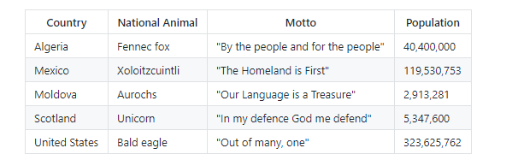

1. Make a page name it demo.html and then make the following tasks in it.

a-Make a form with the following requirements

1. First name input which is text type.
2. Last name input which is text type.
3. Password input which is password type.
4. Age input which is number type.
5. Hobbies (your hobbies at least three) which are of type check boxes.
6. Gender (Male-Female) which of type radio button.
7. Submit button.
8. Make notes of type text area.
9. The form must use post method. Why?
10. When submit go to new page that you will make name it welcome.html and say “Thank you for register”.

b-Make any example that represent image map.

c-Make iframe that contains <https://iti.gov.eg>

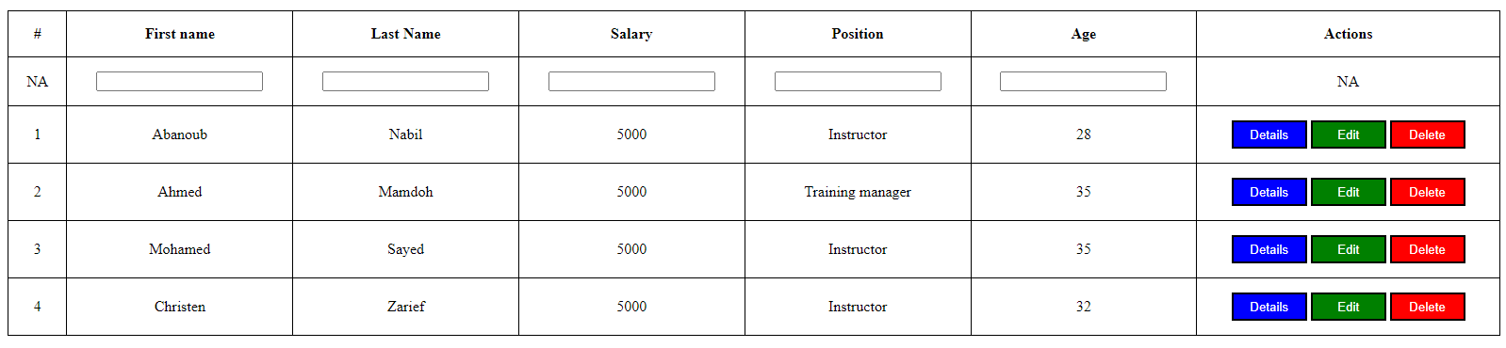 d-Design the following table

e-Design the following form

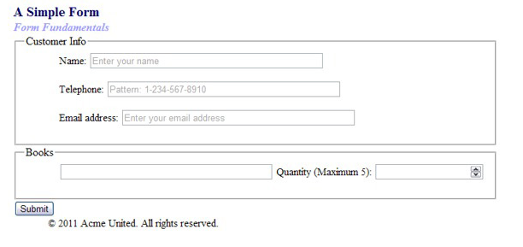

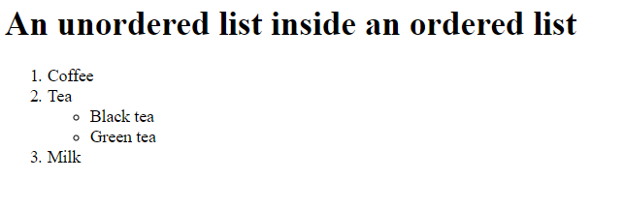 f-Design the following list